**Group Name: TiTechnics**

**Software Construction and Development**

**Deliverable 02**

8th May 2024

Khadija Bibi SP-21424

Fatima Rehmanullah SP-21282

Muhammad Alyan SP-21319

Konain Raza SP-21303

Aazeen Iftikhar SP-21329

**Instructor:** Miss Fatima Gillani

**Software Requirement Specification Document**

**Personal Finance Tracker**

1. **Use case diagram**

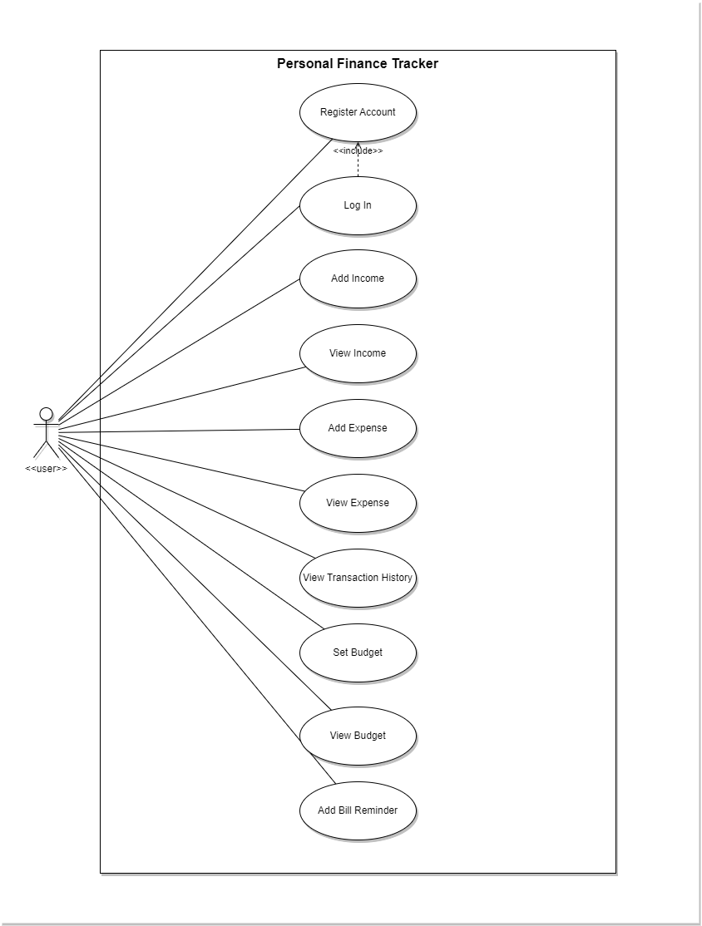

Figure 1 Use Case Diagram

1. **Class diagram**

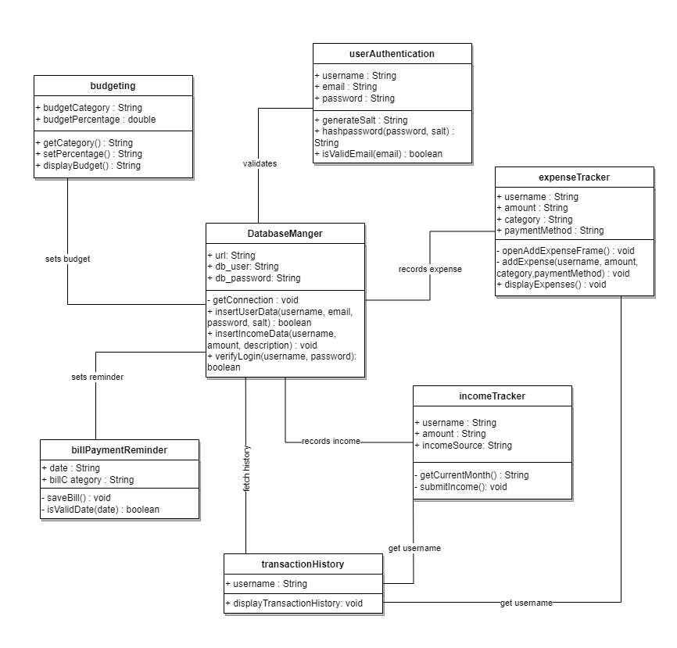

Figure 2 Class Diagram

1. **Package diagram:**

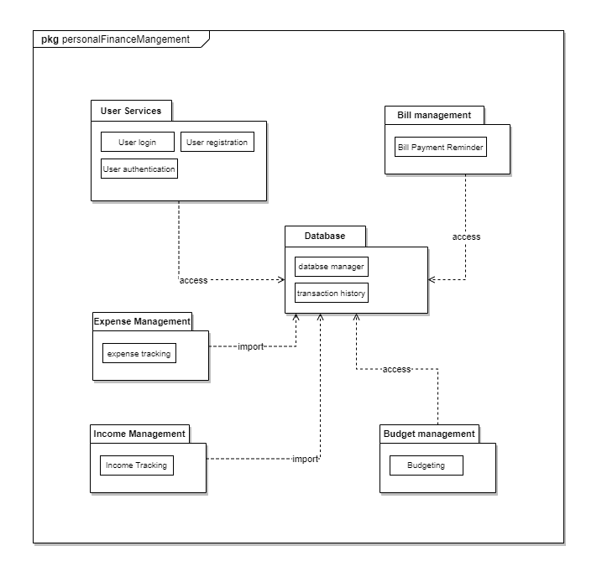

Figure 3 Package Diagram

1. **Timing Diagram:**

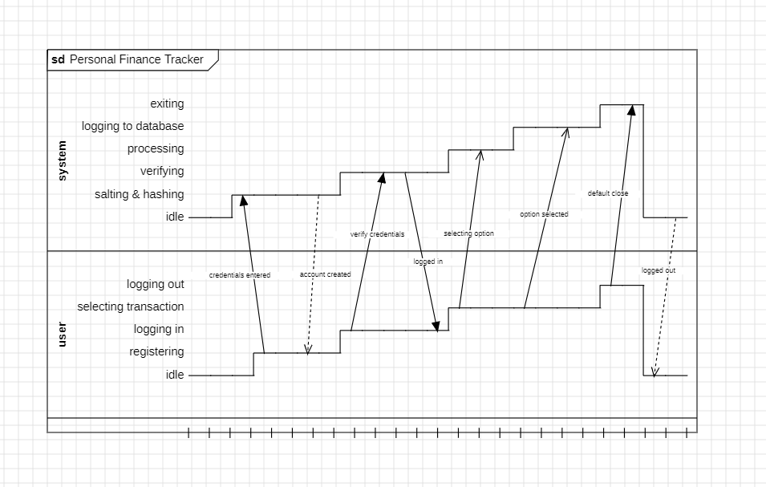

Figure 4 Timing Diagram

1. **Object Diagram:**

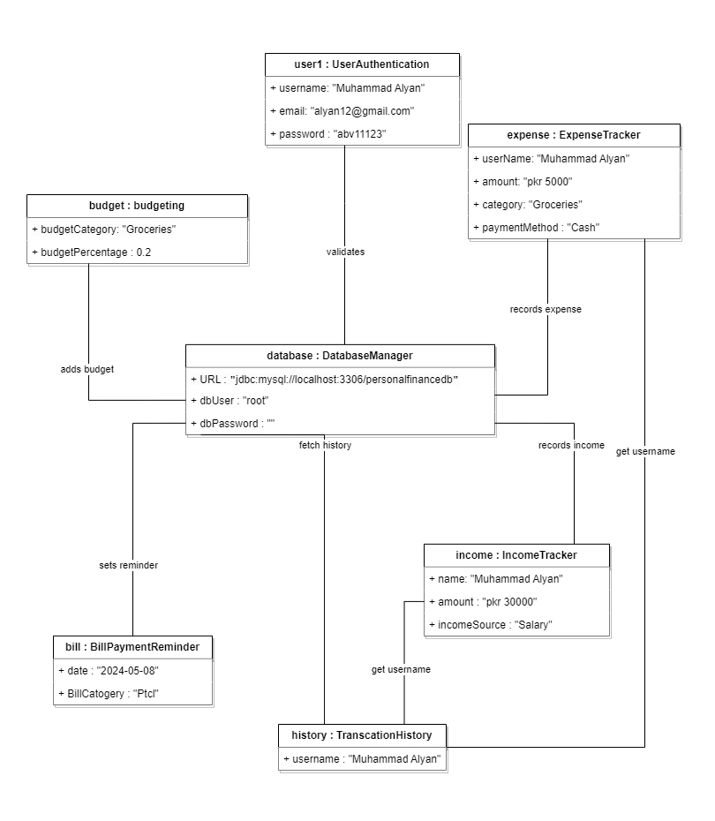

Figure 5 Object Diagram

1. **Communication Diagram**

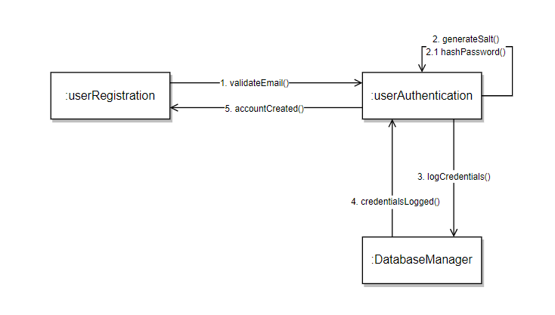

Figure 6 User Registration Communication

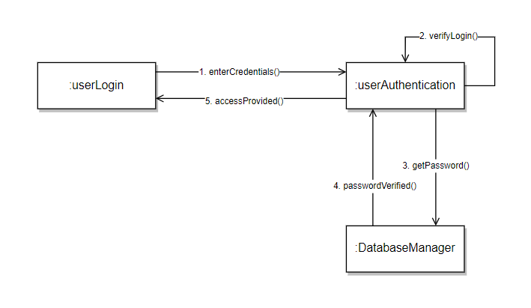

Figure 7 User Login Communication

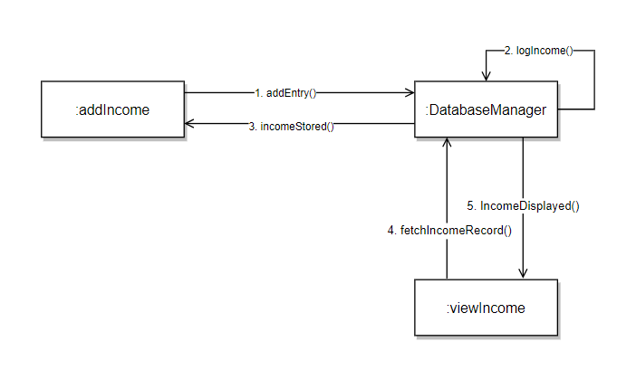

Figure 8 Add Income Communication

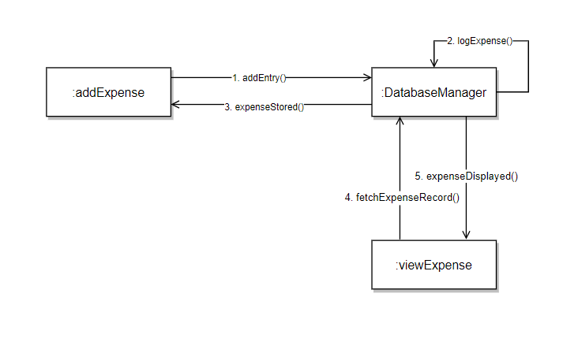

Figure 9 Add Expense Communication

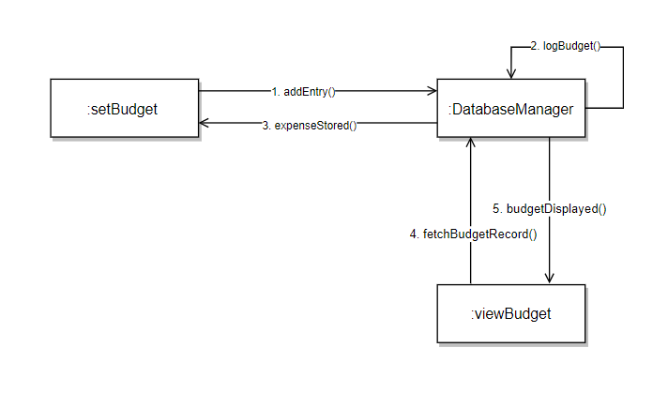

Figure 10 Set Budget Communication

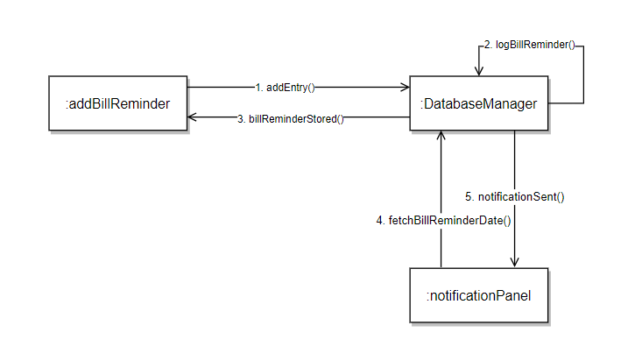

Figure 11 Add Bill Reminder Communication

1. **Petri-nets:**

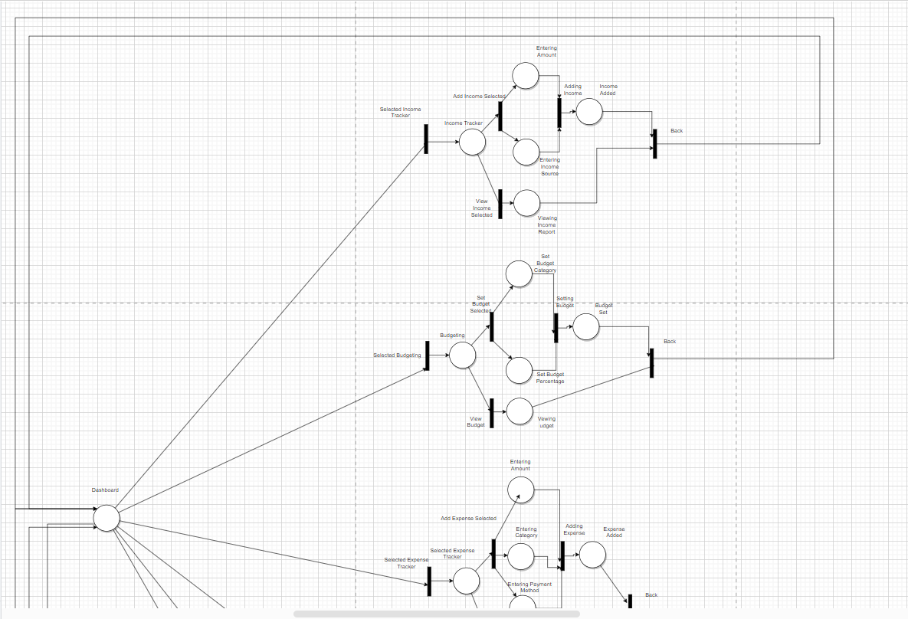

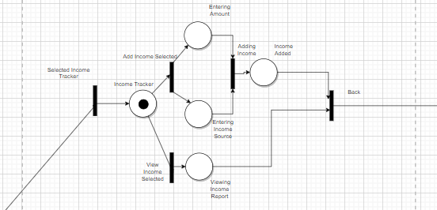

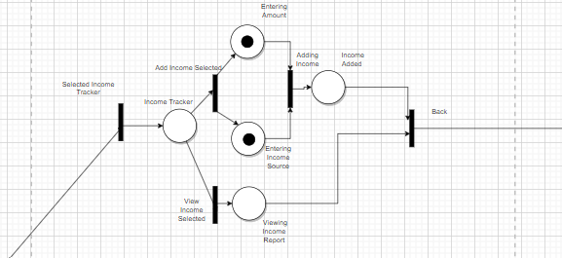

**Alternate transition**

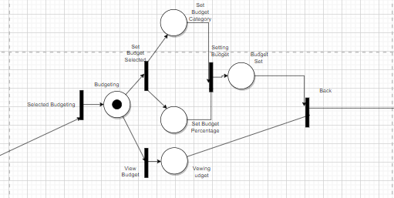

**Alternate transition**

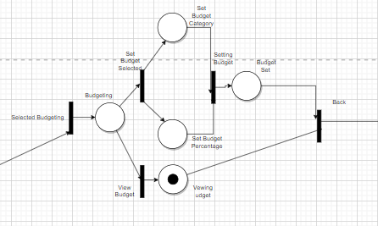

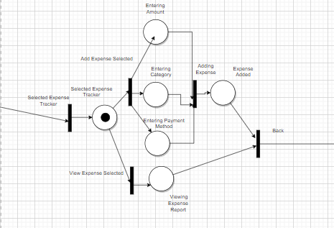

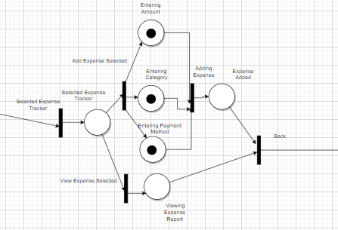

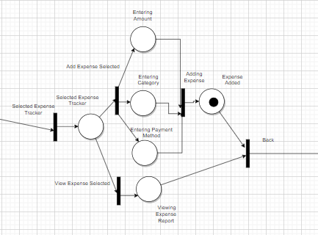

**Alternate transition:**



